Larry Cheever

CMIS 102 6384

**CMIS 102 Hands-On Lab**

**Week 1 – Hello World**

1.

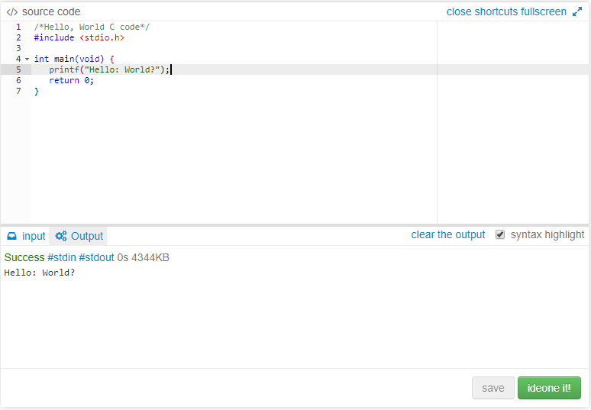

2.